2. Using DBSCAN algorithm:
Which is density – based clustering.
Here the important things are epsilon which is radius.
- (Eps) = 10, it should be higher enough because the small number of closely spaced points that are noise will be incorrectly labeled as clusters.
- Threshold MinPts = 4, because if it less than 7 then will indicated Core points.
- I have chosen some attributes that I can get more useful information and I ignored the others.

- Figure 1. visualized of the disposition:
We can see the core region labeled by 1 and 4 and the bored region number 2,3 and the noise part is omitted.

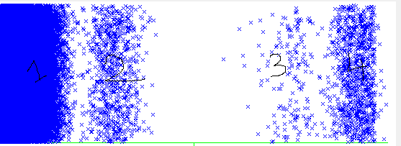

- Figure 2.
Describes the interval, it is very clear the core region in the left side and bored region next to .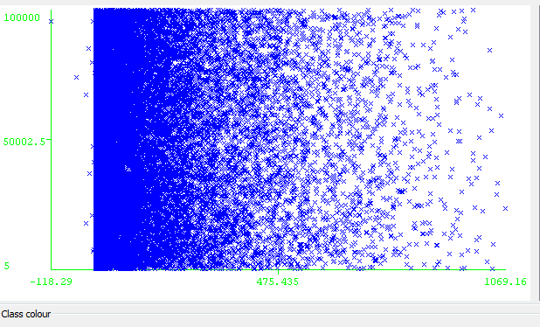

- figure 3.
Visualized for the ages:
The high density labeled for the core region for age between 56 and 100 years so and the bored region around 50.
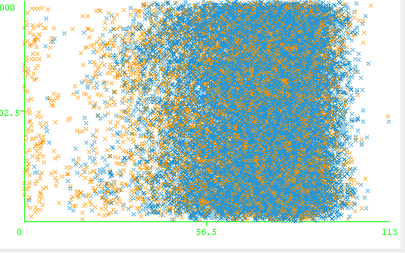
- figure 4.
Visualized for patient-Sex
So the blue color for the core region and the orange color for the bored region

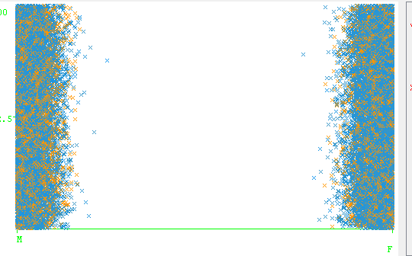

Summary:
- The number of data objects are 37242,
- The disposition has number 1 for the first five clusters.

